Title of the work, with only the first capital letter: the subtitle, if any, should be started in lower case (size 14, single space, bold, centralized)

(size 12, single space, italic, right alignment) Name of the Author
(size 10, single space, right alignment) Institution - e-mail

(size 12, single space, italic, right alignment) Name of the Advisor
(size 10, single space, right alignment) Institution - e-mail

Abstract: abstract of the work with about 250 words (size 10, single space, 2 centimeters of indentation in the left margin, justified). The abstract must contain: presentation of the subject, objectives, theoretical-methodological references and main conclusions of the work.
Keywords: three keywords, separated by a period, with only the initial of each of them in capital letters (size 10, single space, 2 centimeters of indentation in the left margin, justified).

1. Subtitle 1 (size 12, 1.5 spacing, bold, justified)
Text (font size 12, 1.5 spacing, justified alignment and indentation of the first paragraph line of 2 centimeters). "Citations with up to 3 lines must be inserted in the body of the text, in quotation marks" (AUTHOR, year, p. page number).

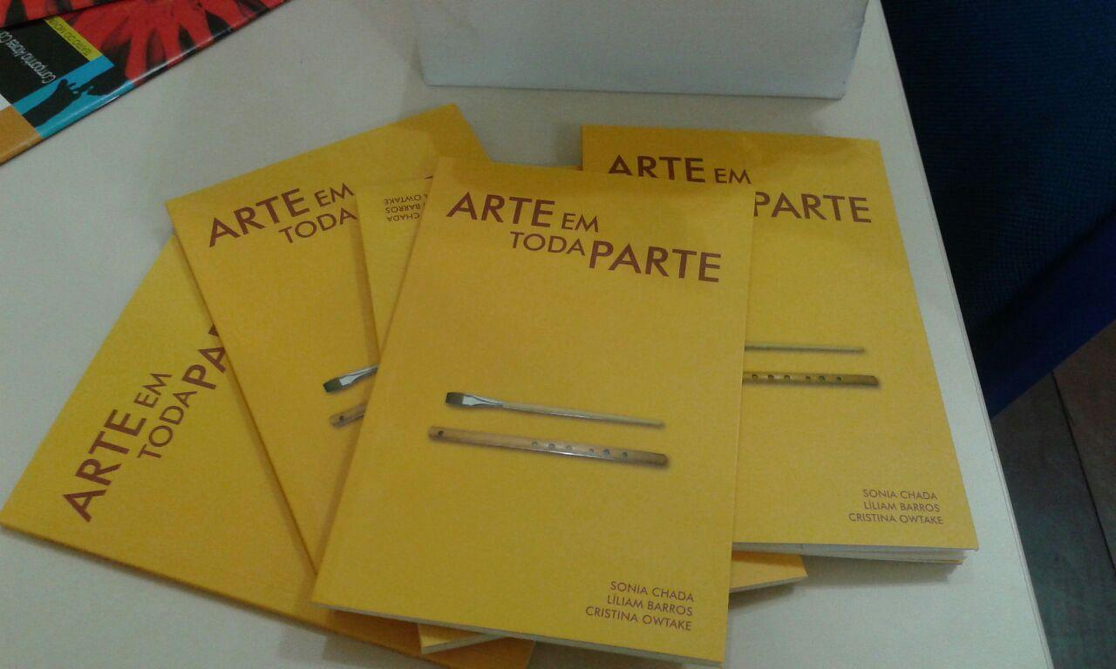
Example 1: Musical examples (Ex.), Figures (Fig.), Tables (Tab.) Etc. they must be inserted in the text as a figure (".tif" or ".jpg" format in 300 dpi), numbered and accompanied by a succinct and clear caption of no more than 3 lines (size 10, single space, centralized). The legend must come below the figure, which should not exceed the margin of the figure.

Citations with more than 3 lines must be separated as a paragraph and with 4 centimeters of indentation on the left - without quotes, font size 10, single space, justified alignment, without italics (AUTHOR, year: page number).

2. Subtitle 2 (Times New Roman font, size 12, bold, justified)
Each work must have a length of up to 3000 words (including title, abstract, keywords and their translations, notes and references).
The author or authors of the work are responsible for the accuracy of the references in the list at the end of the works, as well as the correct citation throughout the text.
Formatting rules that are not provided for above must be in accordance with the current rules of ABNT.

References: (include only the fonts cited in the paper; Times New Roman font, size 12, single space, justified, without indentation, without a blank line between each item).
- Book
SURNAME, Author's first name(s); SURNAME, second Author's first name(s) (if any). Title of the Work: subtitle [if any]. Edition [if not the first]. Place of publication: Publisher, year.

- Book or entry chapter signed in encyclopedia
SURNAME, First name(s) of the Author of the Part of the Work. Part title. In: SURNAME, First name(s) of the Work Organizer (Org.). Title of the Work: subtitle [if any]. Edition [if not the first]. Place of publication: Publisher, year. Chapter or initial-final pages of the part.

- Dissertations or Theses
SURNAME, Author's first name(s). Title of the Work: subtitle [if any]. City, year of defense (if applicable). Number of pages [ex .: 123p.]. Dissertation (Master in ...) [or Thesis (Doctor in ...)]. Institute, University, City, year of publication.

- Article in Journal
SURNAME, First name(s) of the Author of the Article. Title of Article. Title of the Journal, Place of publication, volume number (v.), issue number (n.), Initial-final page of the article (p.), Year of publication.

- Work in Event Annals
SURNAME, Author's first name(s). Title of the work. In: EVENT NAME, event number. (3.), year of realization, location. Annals ... Place of publication: Publisher, year of publication. Initial-final page of the work.

- Published score
SURNAME, Author's first name(s). Title of the Work. Place of publication: Publisher, year of publication. Sheet music.

- Handwritten score
SURNAME, Author's first name(s). Title of the Work. Place of publication: information on the type of graphic record of the work (inform the editor and year of edition, if any), year of composition. Handwritten score.

- CD or video recording
TITLE of the phonographic record: subtitle [if any]. Name(s) and surname(s) of the Composer(s) (include the term Composer in parentheses). First name s) and last name(s) of the Interpreter(s) (include the term Interpreter, instrument, in parentheses). Place of publication: Publisher, year. Support [Compact Disc]. Additional information [if applicable].

- Videos
TITLE of the phonographic record: subtitle [if any]. First Name(s) and Last Name(s) of the Author(s). Production (direction, conducting ...) of Responsible Name. Tape type, recording duration. Place of publication: Publisher or label, year of publication.

- Interviews
SURNAME, Author's first name(s). Interview of the interviewer's First and Last Name on the date of the interview. City. Record type. Place.

- Works published online
SURNAME, Initial of the first name(s) of the Author(s) [if any]. Title of the work: subtitle [if any]. Place of publication: Publisher, year. Available at: <http: // ...>. Accessed in: day month abbreviated year.

- Audiovisual material (moving image) in electronic media:
It includes files in several formats such as MPEG, AVI, FLV, MOV, among others. The essential elements are: Page name, Address, Date of access (When necessary, additional elements are added to the reference to better identify the document: format, size, file name, title, date of recording, director, producer, location , producer, support description.)

GLOBO.COM. Disponível em: <http://video.globo.com/Videos/Player/Noticias/0,,GIM
1241274-7823-SARAU+FAZ+UM+TRIBUTO+A+RENATO+RUSSO,00.html>. Acess in: June 5th, 2010. Sarau faz um tributo a Renato Russo. Apresentação de Chico Pinheiro. Presented on: April 2nd, 2010. Dur: 22m36s.

Footnote (font size 10, single space, justified).

